

**School of Engineering and Information Technology**

**ASSIGNMENT COVER SHEET**

* Please complete and insert this form as the first page of EACH electronic assignment.
* Submit the assignment with attached coversheet electronically as per the instructions in the Assignment Question sheet.
* Please make sure you keep a copy of the assignment.

**Student Details**

|  |  |  |  |
| --- | --- | --- | --- |
| Surname | Vu Hoang | Given name | Quan |
| Student Number | 33679278 | Email | Vuhoangquan1999@gmail.com |

**Assignment details**

|  |  |  |  |
| --- | --- | --- | --- |
| Unit name | Principles of Computer Science | Unit Code | ICT167 |
| Unit Coordinator | Kevin Wong | Tutor/Tutorial time |  |
| Due date/time | 7April 2019 | Submission date | 8 April 2019 |
| Assignment title | Assignment 2 | | |
| Other information |  | | |

***All forms of plagiarism, cheating and unauthorized collusion are regarded seriously by the University and could result in penalties including failure in the unit and possible exclusion from the University. If in doubt, please contact the Unit Coordinator.***

**Student’s Declaration**

Please double click on all the check boxes.

Except where I have indicated, the work I am submitting in this assignment is my own work and has not been submitted for assessment in another unit.

This submission complies with Murdoch University policies regarding plagiarism, cheating and collusion.

I have retained a copy of this assignment for my own records.

Assignment 2 ICT167 - Principles of Computer Science

Author: Vu Hoang Quan

Date: 8/4/2019

**Requirements/Specification**:: design a program to input students information from file and calculate their average scores, marks, grades, find their information, and sort those infomation

**User Guide:** put all students infomation in text file inplutsample.txt in form: id;title;surname;givenname;date;month;year of birth;weektutorial mark;assignment 1 score; assignment 2 score; assignment 3 score;final exam score;education level;

Separate this information by “;” with no additional space.

Name can have space.

**Structure/Algorithm:**

Program will promt user and let them see the menu at the start

Enter from 1 – 9 to access functions of this program.

Enter 1 will end program.

Enter 2 will input from file.

Enter 3 will output all student info.

Enter 4 will output average overall mark of all student.

Enter 5 will show how many student have higher score than average and vise versa.

Enter 6 will search base on ID entered (repeated ID in file will make this found only the last ID in file).

Enter 7 will search by surname and given name (full name must be entered and with “space” as normal, can be enter by firstname lastname or vise versa ).

Enter 8 will sort IDs in asccending order and output all information.

Enter 9 will sort Surname in asccending and display all information by using a scoring system (“a” will be first, “b” will be second… “z” will be last)

**Design:**

Any number input not from 1 – 9 will repeat the program

Function 2 which is read from file only needed to run once

After enter 2, if there are repeated infomation in file, program will warn user

File can have as many student information as wanted. The program will automatically reize its object to fit

**Limitations:**

Enter 9 only sort all Surname by the first letter.

User interaction and logic are mixed in Student and Function class

**Testing**:

Inputsample.txt file:

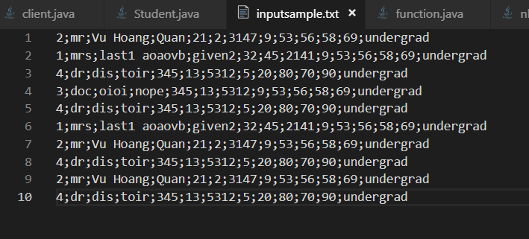

Output sample:

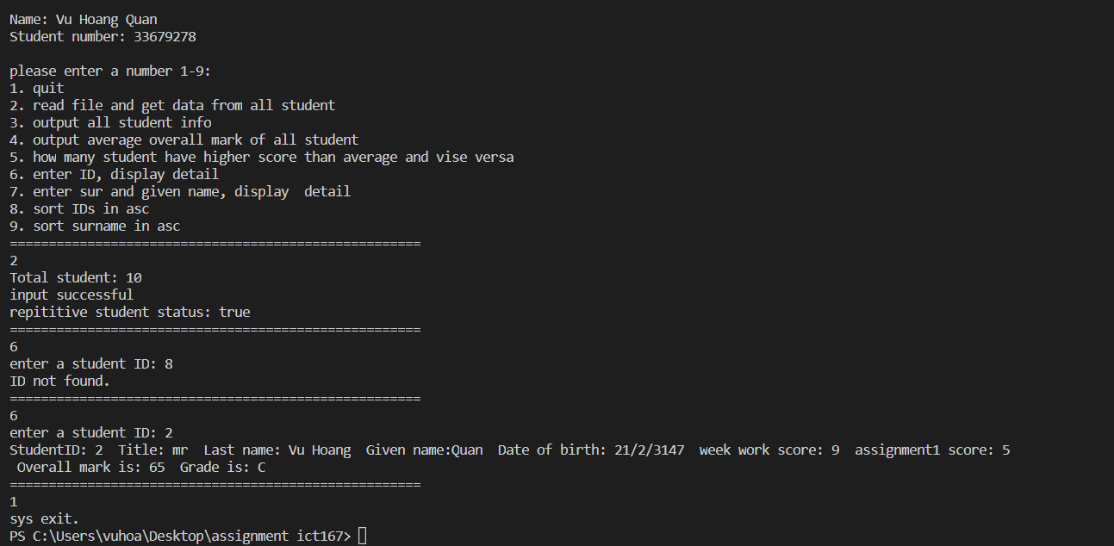

Another output sample:

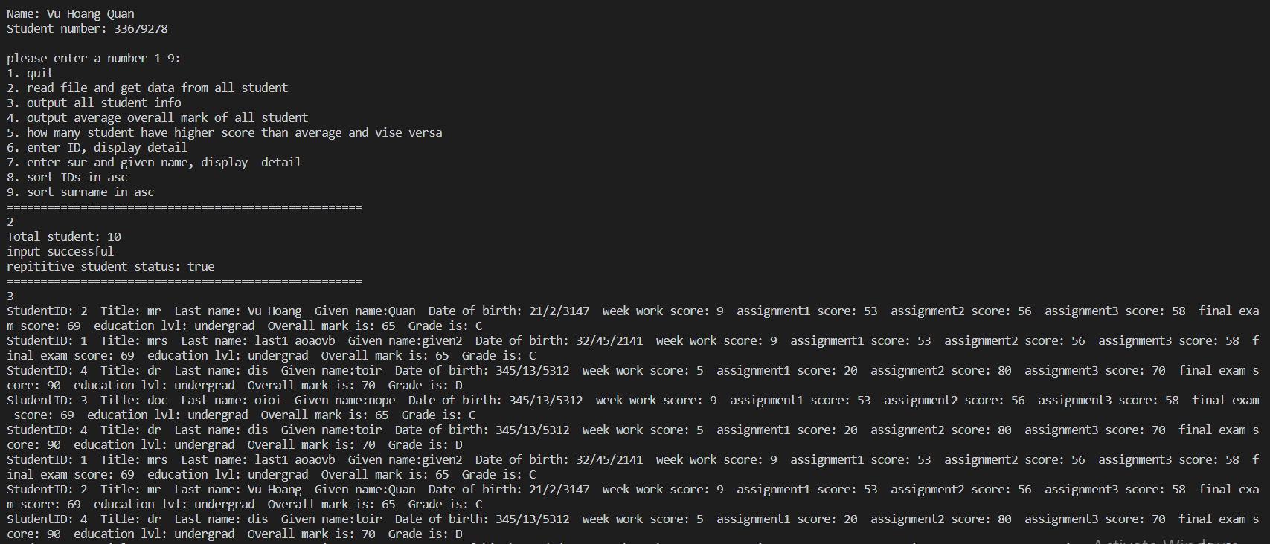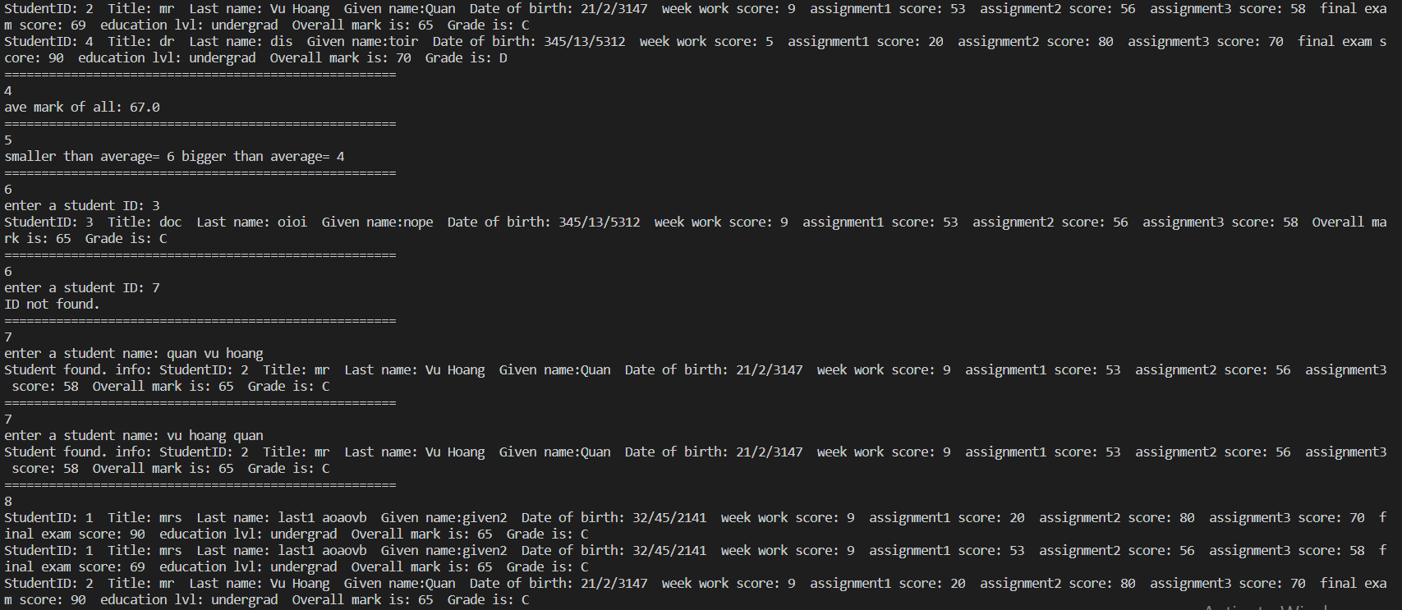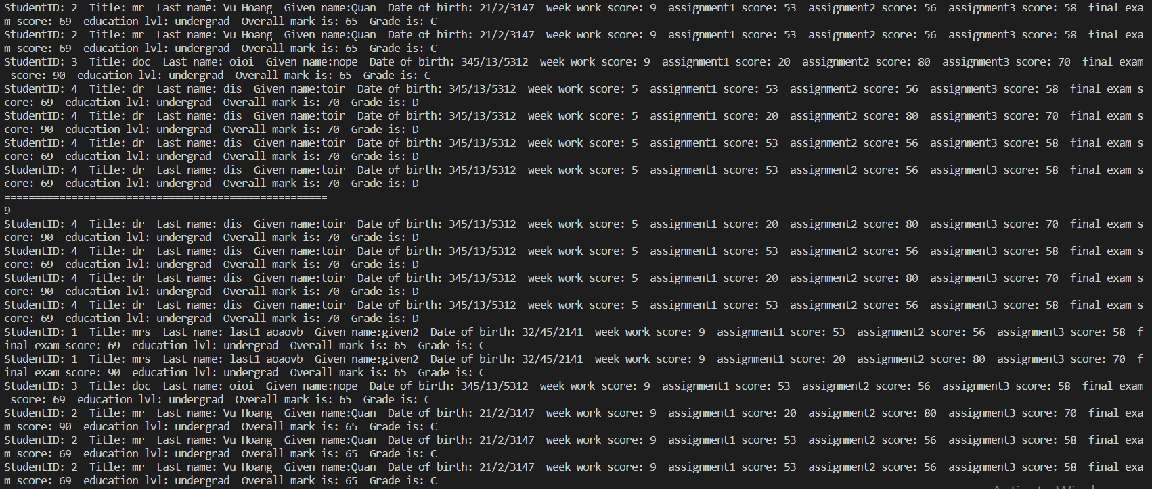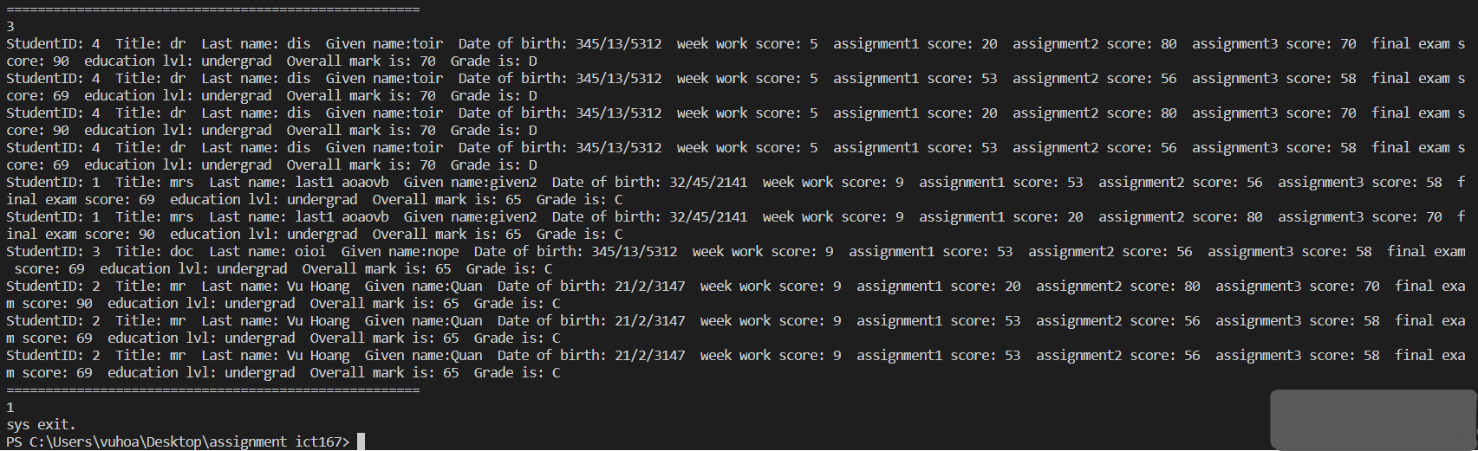

Input sample:

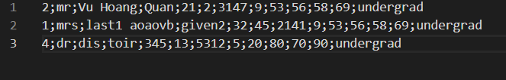

Output:

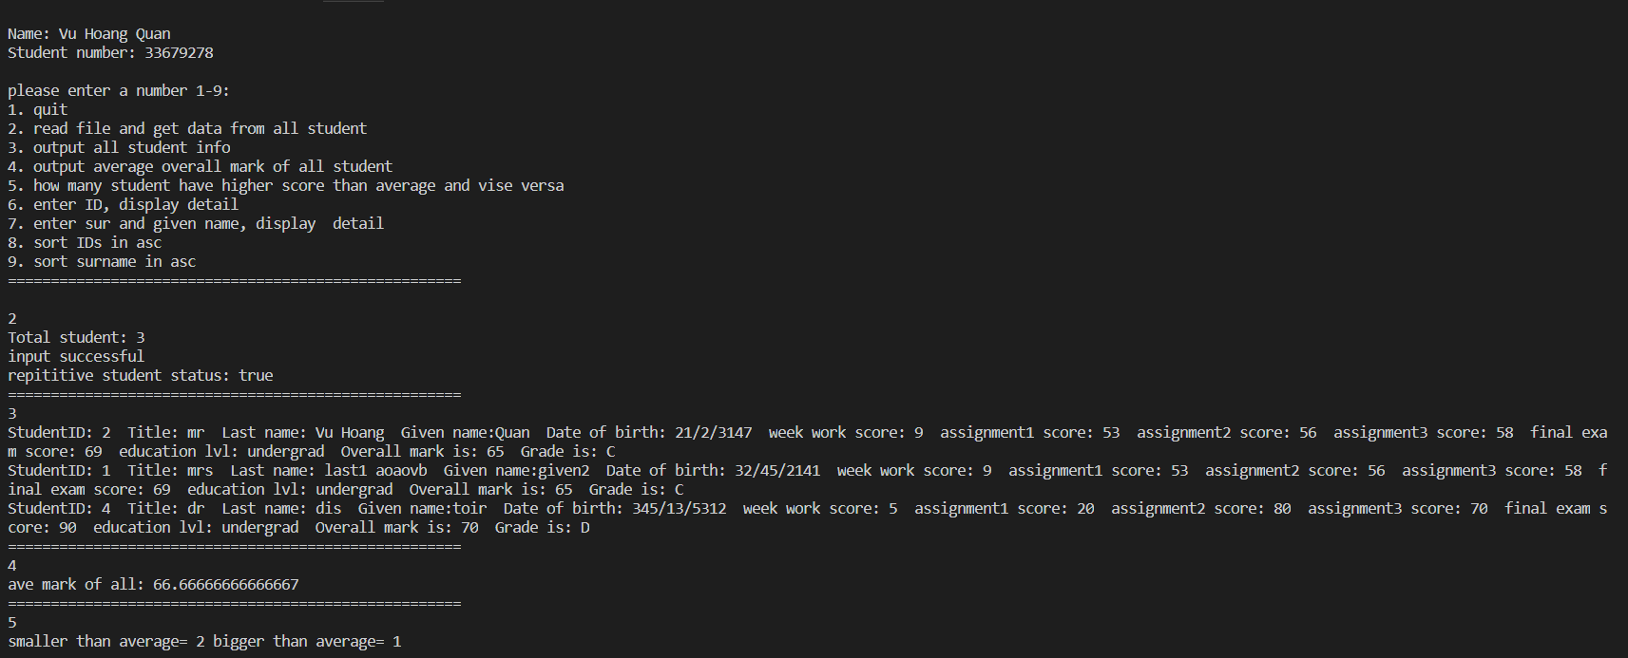

**Source program listings:**

File names:

* Folder: ict167 assignment 2 contains:
  + Files:
    - client.java,
    - function.java,
    - inputsample.txt,
    - PostGraduateStudent.java,
    - Student.java,
    - UndergraduateStudent.java